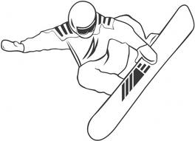2016-17 LCA Ski/Board Club

Ski Club is open to all 5-12 grade LCA students interested in recreational skiing/snowboarding. There is room for 40 members.

Cost - Membership is $225. Checks to LCA. Due December 1. Cost covers lift ticket and transportation for 5 of the 6 trips, for $30 more you can go on all 6 trips. Rental is additional cost, listed below. Please fill out Emergency Form and turn in with your check. You are more than welcome to bring your own equipment. Club sweatshirts will be available for $10, please notify me of size if you want one.

Guest fee is $45. Guests must be approved prior to the trip by Mr. Manske. We have a limited amount of space on the bus, so those who are checked in early will have first rites to the open spots.

Families are welcome to come or join us at the hill at discounted rates.
Questions? Mr. Manske’s cell phone ~ 612.202.6818, school ~ 763.427.4595 ext. 282,
email ~ tmanske@lcamn.org

Rental (Checks to LCA)
- Afton - $21 skis or snowboard - pay at rental counter
- Welch - $15 skis or snowboard, helmet $7 - pay Mr. Manske
- Wild Mountain - $20 skis or snowboard, helmet free - pay Mr. Manske
- Trollhaugen - $19 ski or snowboard - pay Mr. Manske

Ski/Board Lessons - $0-$15 depending on which hill, or Mr. Manske can also help you with ski and snowboard instruction.

Schedule
Bus leaves promptly at departure times. No club members may drive themselves. We will stop for food on the return trips. Please sign up for Remind 101 for text message updates on cancellations or announcements. Follow these 4 steps
- Text @lcaski to 81010
- You will receive a text message back asking for your full name
- Reply with your full name (first and last)
- You will now receive text messages

Here are all of the trips. Remember that you can pick 5 of the 6 trips.
All trips leave LCA – 2:00 pm, Arrive – 3:30 pm, Depart – 8:45 pm, Arrive LCA – 11:00 pm

Date Destination Date Destination

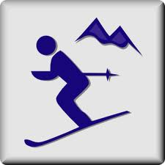Dec. 10 Wild Mountain Jan. 6 (Fri) Trollhaugen
Jan. 20 (Fri) Afton Feb. 4 Welch Village
Feb. 10 (Fri) Wild Mountain Feb. 25 Afton

If we have any cancellations, make-up dates are February 17 and March 4.
We will not go if wind chill is -5 or temp is below 0.

